Corrigendum
Corrigendum to “Environmentally friendly, rheoreversible, hydraulic-fracturing fluids for enhanced geothermal systems”
[Geothermics 58 (2015) 22-31]

Hongbo Shaoa, Senthil Kabilana, Sean Stephensa, Niraj Suresha, Anthon N. Becka, Tamas Vargaa, Paul F. Martina, Andrew Kuprata, Hun Bok Junga, Wooyong Uma, Alain Bonnevillea, David J. Heldebranta, Kenneth C. Carrollb, Joseph Moorec, Carlos A. Fernandeza,∗

a Pacific Northwest National Laboratory, Richland, WA 99352, United States
b New Mexico State University, Las Cruces, NM 88003, United States
c Energy & Geoscience Institute, Salt Lake City, UT 84108, United States

Note to the editor: In the original article some permeability values were underestimated, in particular, for rock samples fractured by the stimuli-responsive fracking fluid (PAA-CO₂). In addition, effective pressures were determined to be lower for three control experiments (deionized water-carbon dioxide, DIW-CO₂). Therefore, we revised values of permeability and effective pressure as well as performed additional lab-scale stimulation experiments under identical conditions to further verify/update the deductions presented in the discussion section. This is the reason for the additional data introduced in the below Table 1 (grey color).
The authors regret the following inadvertent errors and corresponding modifications. These modifications do not change the scientific conclusions of the article.
1. On page 26, Table 1 should be replaced/updated by the new Table 1 (below). Additional data was introduced in this new Table 1, highlighted in grey color.
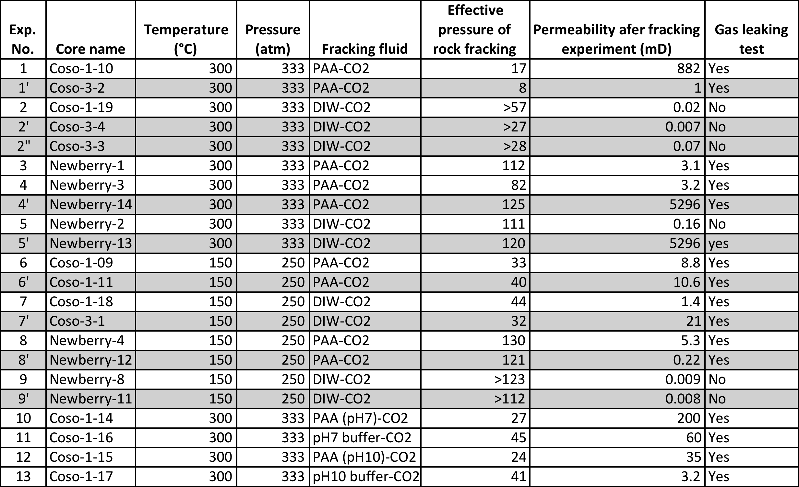

2. Page 1: Please add M. Ian Childers as an author to the original manuscript since Dr. Childers is the scientist that performed the additional experimental work shown in Table 1 (data highlighted in grey).
3. Page 25: In the original article right column line 9 after it reads “17atm” add “(and 8atm for a duplicate experiment, Table 1 entry 1’)”.
4. Page 25: In the original article right column line 10 where it reads “was not fractured even when the internal pressure was 170 atm higher” it should read “was fractured although the internal pressure was 57atm above the confining pressure and the fractures were not detected during XMT analysis”
5. Page 25: In the original article right column line 12 where it reads “(note that at this effective pressure, the pressure of CO₂ was actually near the upper limit of the ISCO pump)” it should read “(note that two additional control experiments on similar rock samples under identical conditions also generated very small microfractures, not visible in XMT, with negligible permeability and at pressures as high as 27 and 28atm, entries 2’ and 2” in Table 1)”
6. Page 25: In the original article right column line 23 where it reads “8.8mD” it should read “880mD”.
7. Page 25: In the original article right column line 31 after it reads “for 5min.” add “(two additional duplicate experiments on similar rock cores under identical conditions also showed no measurable permeability using water, entries 2’ and 2” in Table 1)”.
8. Page 25: In the original article right column line 31 where it reads
“Based on this result, we estimate that the permeability of Coso-1–19 after fracturing experiment is less than 0.001 mD. Thus, the permeability of Coso rock core fractured with a conventional fracturing fluid (Coso 1–19) is at least three orders of magnitude lower than the permeability of a Coso rock core fractured with PAA–CO₂ fracturing fluid (Coso 1–10)”

it should read

“Based on these results, we estimated the permeability of all three Coso rock cores from the control experiments (Coso-1–19, Coso 3-3, and Coso 3-4) using CO₂ pressurized to 10atm (instead of water) obtaining permeability values of 0.02mD, 0.07mD, and 0.007mD, respectively. Thus, the permeability of Coso rock cores fractured with a conventional fracturing fluid is between two to six orders of magnitude lower than the permeability of Coso rock cores fractured with PAA–CO₂ fracturing fluid (Coso 1–10, and Coso 3-2)”

9. Page 25: In the original article right column line 41 after it reads “17atm” add “(and 8atm for a duplicate experiment, Coso 3-2)”.
10. Page 25: In the original article right column line 42 where it reads “more than 170atm for an identical rock core (Coso 1-19, control experiment),” it should read “57atm, 27atm, and 28atm for similar rock cores (Coso 1-19, Coso 3-3, and Coso 3-4; all control experiments)”.
11. Page 25: In the original article right column line 45 after it reads “crystalline rock” add “at significantly (1/3) lower effective pressures than conventional fluids”.
12. Page 25: In the original article right column line 52 where it reads “core (Newberry-02) was not fractured even when internal pressure was 170atm higher than the confining pressure.” it should read “cores (Newberry-02, and Newberry-13) fractured with internal pressures that averaged 116atm higher than the confining pressure.”
13. Page 25: In the original article right column line 54 where it reads “Similarly to the control experiment for Coso field rock core (Coso 1–19), no N₂ leaking was observed for Newberry-02 after the fracturing experiment.” it should read “N₂ leaking was observed for Newberry-02 and Newberry-13 after the fracturing experiment though in one case it was very difficult to observe due to the low permeability post-fracturing (0.16mD, Newberry-02).”
14. Page 25: In the original article right column line 57 where it reads “When employing PAA–CO₂ as a fracturing fluid, however, similar Newberry rock cores [Newberry-01 (experiment #3) and Newberry-03 (experiment #4)] were successfully fractured at significantly lower effective pressures (see Table 1).” it should read “When employing PAA–CO₂ as a fracturing fluid, however, similar Newberry rock cores (Newberry-01, Newberry-03, and Newberry-14) were successfully fractured at (on average) nearly 10% lower effective pressures (see Table 1).”
15. Page 25: In the original article right column line 62 where it reads “was similar (0.031 and 0.032 mD, respectively) (Table 1), showing an increase in permeability with respect to the original unaltered Newberry rock samples of over four orders of magnitude (0.032 mD vs. 10⁻⁶ mD)” it should read “was 3.1mD, 3.2mD, and 5296mD (Table 1), showing an increase in permeability with respect to the original unaltered Newberry rock samples between six and nine orders of magnitude (3.1 - 5,296mD vs. 10⁻⁶ mD)”
16. Page 26: In the original article left column line 9 in Section 3.1.1.2 where it reads “significantly lower” it should read “similar”
17. Page 26: In the original article left column line 10 in Section 3.1.1.2 where it reads “rock cores, and that the experimental permeability of the generated fracture networks is considerably and consistently higher than those obtained using DIW/CO₂ (control experiments)” it should read “rock cores. However, the experimental permeability is, in most experiments, considerably higher than those obtained using DIW/CO₂ (control experiments)”
18. Page 26: In the original article left column line 13 in Section 3.1.1.2 where it reads “(Coso 1-9) the sample was fractured with an effective stress of 34atm while a nearly 50% increase in effective stress” it should read “(Coso 1-9 and Coso 1-11) the samples were fractured with an average effective stress of 36.5atm while similar average effective stress (38atm)”
19. Page 26: In the original article left column line 15 in Section 3.1.1.2 where it reads “an identical sample (Coso 1-18)” it should read “two similar samples (Coso 1-18 and Coso 3-1)”
20. Page 26: In the original article left column line 17 where it reads “In addition, the experimental permeability value for the Coso sample fractured with the PAA–CO₂ fluid system was in the order of several mD, which is nearly four orders of magnitudes higher than the experimental permeability obtained in a Coso rock sample fractured with the conventional fracturing fluid (Coso 1–18)” it should read “However, with the PAA–CO₂ fluid system the permeability values were consistently high and the fractures visible in XMT as compared to Coso rock samples fractured with the conventional fracturing fluid (Coso 1–18 and Coso 3-1) where in one out the two experiments the fractures were not visible in XMT and the permeability was six times lower than the lowest permeability value obtained with PAA/CO₂ fluid.”
21. Page 26: In the original article right column line 16 after it reads “networks.” add “and significantly (two to three orders of magnitude) lower permeability values under similar (to PAA-CO₂) applied overpressures.”
22. Page 26: In the original article right column line 17 where it reads “(1) similarly to previous high temperature experiments, under low temperature and pressure conditions, PAA–CO₂ fracturing fluids can generate highly permeable fracture networks in highly impermeable crystalline rock cores from both Coso and Newberry geothermal sites at significantly lower effective stress than the cores subjected to hydraulic fracturing with DIW–CO₂ (control experiments)”
it should read
“(1) under low temperature and pressure conditions, PAA–CO₂ fracturing fluids can generate highly permeable fracture networks in highly impermeable crystalline rock cores from both Coso and Newberry geothermal sites at similar effective stress than the cores subjected to hydraulic fracturing with DIW–CO₂ (control experiments)”
23. Page 27: In the original article left column line 1 where it reads “(2) the permeability of the fracture networks generated with PAA–CO₂ is several orders of magnitude higher than” it should read “is, in most cases, several times or several orders of magnitude higher than”
24. Page 27: In the original article left column line 10 where it reads “only 17atm” it should read “only 8atm and 17atm”
25. Page 27: In the original article left column line 11 where it reads “Coso-1–10 at 300◦C–333 atm with PAA–CO₂ fluid systems, more than twice as high (effective) pressure (34 atm)” it should read “Coso-1–10 and Coso 3-2 at 300◦C–333 atm with PAA–CO₂ fluid systems, nearly three times as high (effective) pressure (33atm and 40atm)”
26. Page 27: In the original article left column line 14 after it reads “250atm” add “with the same PAA-CO₂ fluid system.”
Page 30: In the original article right column line 11 after it reads “and” add “/or”.

The authors would like to sincerely apologize for any inconvenience caused.

